SPARK: Simple Play Adaptations to Reference for Kids

Social Story Book by Carol Gray
Description: | Image:
This book features stories that help modify behavior and teach life skills with visual prompt-pictures that make the stories even more effective. It includes many of the most requested social stories for: People & Pets, Helping Around the House, Personal Care, Cooking/Mealtime Routines, Time for School, Shopping/Restaurants, Holidays/Vacations/Recreation, and How to Write A Social Story. | 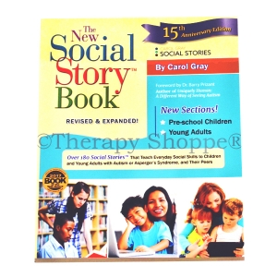  Purchasing Information  About Social Stories by the author

Who Might Benefit?
Those who…
• Want to fit in and play with peers, but can’t figure out how.
• Become anxious in new situations.
• Have difficulty making positive behavioral choices.
• Lack perspective about how their behavior affects or looks to others.
• Need help making sensory choices to maintain or regain self control.
• Do well when they can follow a specific routine or schedule.

Why Use?
Provides an opportunity to…
• Begin to develop independent self-regulation skills (e.g. I Can Make Good Choices).
• Choose an acceptable behavior or reaction to a given situation (e.g. When The Schedule Changes).
• Understand social situations and learn positive behaviors (e.g. Asking a Friend to Play).
• Gain perspective of their behavior choices based on what it looks like to others.
• Learn new skills or enjoy new experiences because they have had the opportunity to learn what to expect (e.g. First Day of School).
• Anticipate what comes next in routines or schedules (e.g. When It is Time to Go Home).
Instructions for Use: | Adaptation Ideas:
Environmental Considerations  - Social stories should be available in the environment in which they are intended and available for the child to look at.  Basic Play/Use  - Social Stories are most effective when introduced before the situation occurs. They should be read or talked about often so that the child understands what to do.  - Social Stories are not generally effective if the child is having difficulty dealing with the situation.  Extended Play/Use  - Review social story following targeted situations and discuss outcomes.  Play/Use with Others  - Social Stories have been designed to be used individually for targeted behaviors but can be used in whole groups as well as a form of class expectations. | Optional Additional Materials/Supplies  - Laminating supplies or sheet protectors for durability.  Simplify It  - Simplify by using short sentences at child's level of understanding.  Add Sensory Cues  - Use alternatives to paper and text social stories using PowerPoint or video format. For example, YouTube video Moving From One Activity To Another  Communication Support  Add picture symbols, photographs, or the child’s drawings so that the content is meaningful and understandable to the child.  Alternative Uses  - Use to teach self-care routines and task completion.  DIY Alternatives  - Create “Comic Strip Conversations” (a concept developed by Social Stories author Carol Gray) by drawing, or having the child draw as you discuss situations, their effect on the child or others, and what to do about them together.

Additional Considerations:

Compose social stories with the child whenever possible, seeking their opinion and perspective.

Keep your stories available and organized using a notebook or computer folder.

Edit Social Stories if needed as situations change to keep them relevant.

Resources:

See Social Narratives from OCALI’s Autism Center Grab and Go Resource Gallery of Interventions

For further information, visit the Social Narratives Autism Internet Module

Like Social Stories, Power Cards teach and reinforce academic, behavioral, organizational, and social skills. Power Cards are visual supports that include an individual’s special interest. See Power Cards from OCALI’s Autism Center Grab and Go Resource Gallery of Interventions

Reminder Cue Cards from OCALI’s Autism Center Grab and Go Resource Gallery of Interventions help teach and remind individuals how to engage in positive behaviors. Reminder Cue Cards provide “what to do” suggestions when an individual is feeling anxious, stressed, or confused. They also support interactions with peers, and offer ways to self-regulate, and manage emotions.

Practical Strategies for Teachers/Caregivers: Teaching Social Emotional Skills from the Center on the Social Emotional Foundations for Early Learning

Ohio Early Learning Standards:
- SE: Self Awareness: Develops an understanding of emotions (1.b.).
- SE: Self Awareness: Begins to manage emotions and actions (2.a.).
- SE: Social Awareness: Develops empathy toward and understanding of others (3 a.).
- SE: Relationship Skills: Develops ability to use simple strategies to resolve conflicts with peers (4.c.).

Words to Encourage Play/Use
Read   | Listen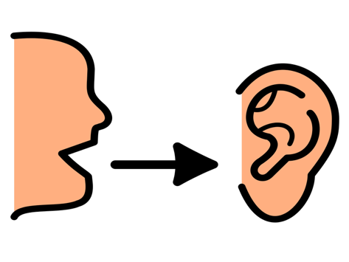 | Sit
Look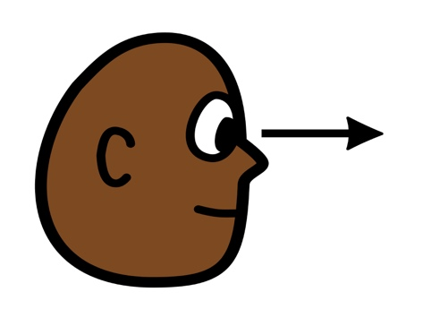 | Turn | Help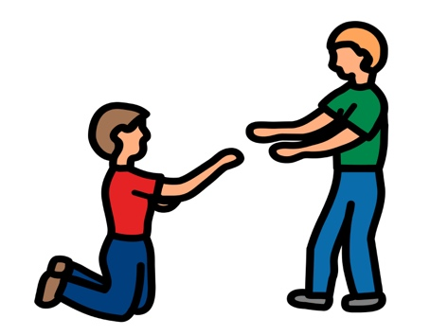
Next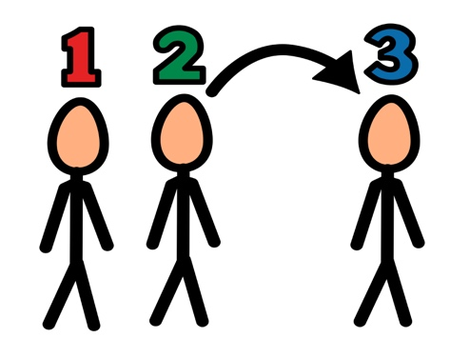 | Ready | Done
*”Adaptations” adapted from: Haugen’s Modes for Adapting Toys based on materials from the "Let's Play" Project at the University of Buffalo
PCS is a trademark of Tobii Dynavox, LLC. All rights reserved. Used with permission.

